**Day2 Assignment:**

1)      Alter Table:

* Add a new column linkedin_profile to employees table to store LinkedIn URLs as varchar.

***Script:*** *ALTER TABLE employees add column linkedin_profile varchar(100);*

***Screenshot:***

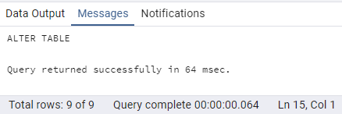

* Change the linkedin_profile column data type from VARCHAR to TEXT.

***Script:*** *ALTER TABLE employees alter column linkedin_profile type text;*

***Screenshot:***

**

* Need to update the null values with unique values to make the column as Not Null and Unique.

***Script:*** *UPDATE employees set linkedin_profile = 'https://linkedin.com/placeholder-' || "employeeID" where linkedin_profile is NULL;*

***Screenshot:***

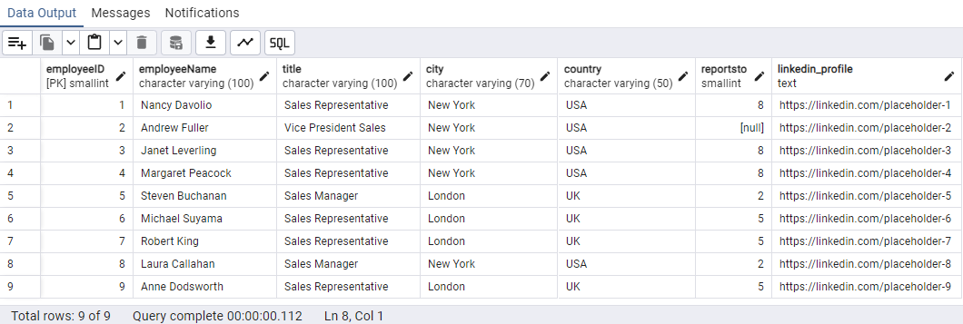

* Adding Not Null Constraint

***Script:*** *ALTER TABLE employees alter column linkedin_profile set NOT NULL;*

***Screenshot:***

**

* Adding Unique Constraint

***Script:*** *ALTER TABLE employees ADD CONSTRAINT unique_linked UNIQUE (linkedin_profile);*

***Screenshot:***

**

* Dropping the column

***Script:*** *ALTER TABLE employees drop column linkedin_profile;*

***Screenshot:***

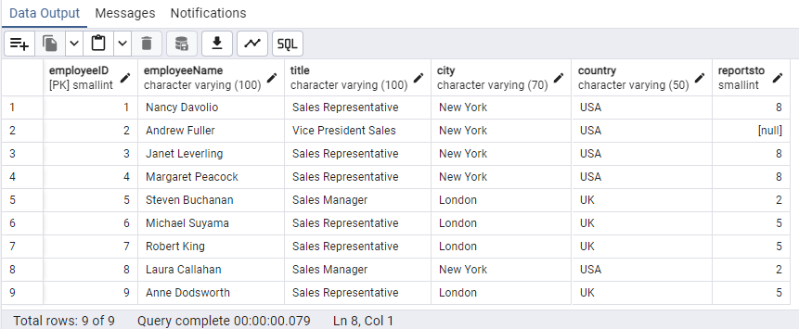

2)      Querying (Select)

* Retrieve the employee name and title of all employees

***Script:*** *SELECT "employeeName",title from employees;*

***Screenshot:***

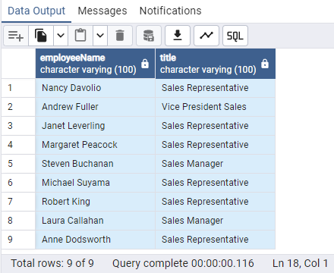

* Retrieve the first name, last name, and title of all employees

***Script:*** *SELECT SPLIT_PART("employeeName",' ',1) as first_name,SPLIT_PART("employeeName",' ',2) as last_name, title from employees;*

***Screenshot:***

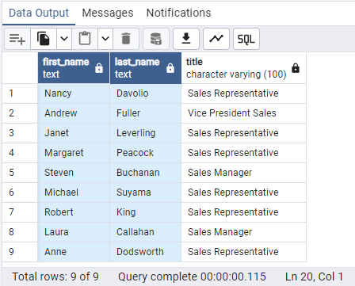

* Find all unique unit prices of products

***Script:*** *SELECT DISTINCT unitprice FROM products ORDER BY unitprice;*

***Screenshot:***

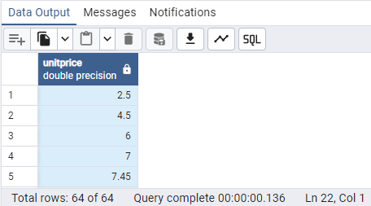

* List all customers sorted by company name in ascending order

***Script:*** *SELECT * FROM customers ORDER BY "companyName"*

***Screenshot:***

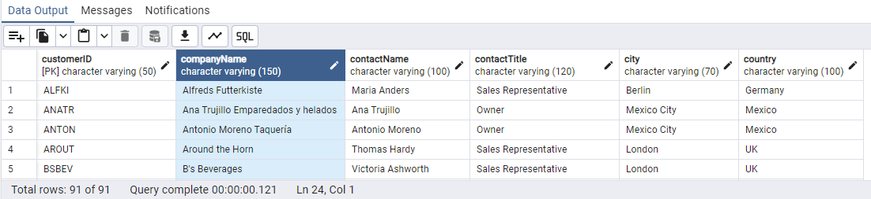

* Display product name and unit price, but rename the unit_price column as price_in_usd

***Script:*** *select productname,unitprice as price_in_usd from products;*

***Screenshot:***

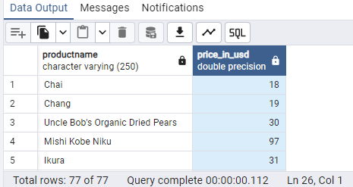

3)      Filtering

* Get all customers from Germany.

***Script:*** *select * from customers where country = 'Germany';*

***Screenshot:***

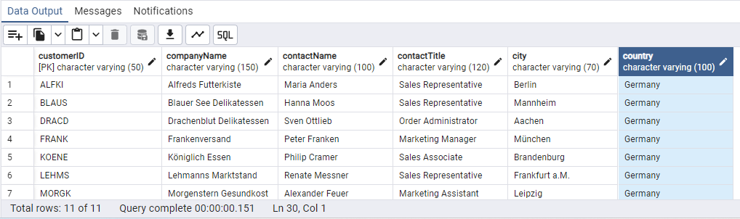

* Find all customers from France or Spain

***Script:*** *select * from customers where country in ('France','Spain') ORDER BY country;*

***Screenshot:***

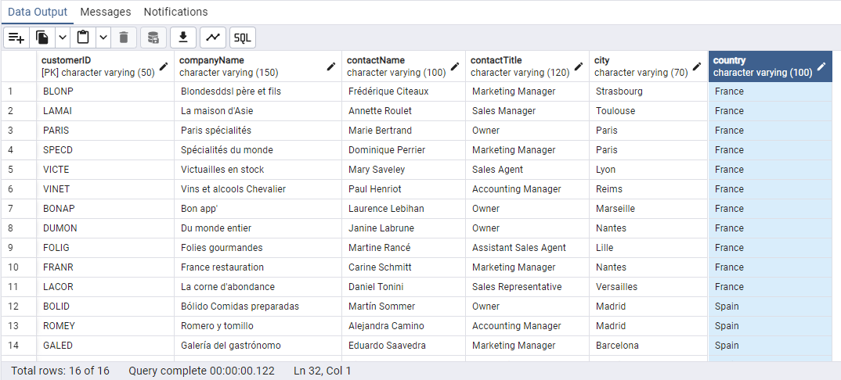

* Retrieve all orders placed in 2014(based on order_date), and either have freight greater than 50 or the shipped date available (i.e., non-NULL)  (Hint: EXTRACT(YEAR FROM order_date))

***Script:*** *SELECT *,*

*EXTRACT(YEAR FROM orderdate) AS ordered_year*

*FROM orders*

*WHERE (freight > 50 OR shippeddate IS NOT NULL)*

*AND EXTRACT(YEAR FROM orderdate) = 2014;*

***Screenshot:***

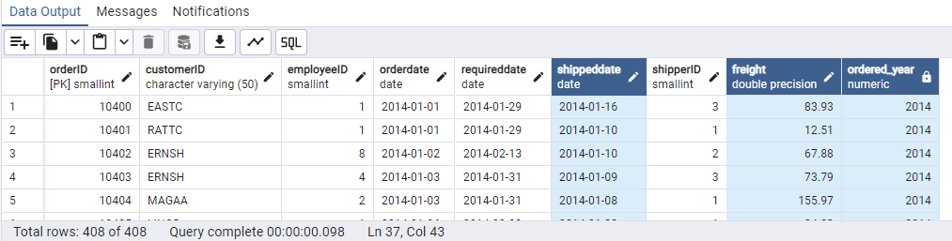

4)      Filtering

* Retrieve the product_id, product_name, and unit_price of products where the unit_price is greater than 15.

***Script:*** *select "productID",productname,unitprice from products where unitprice > 15 order by unitprice;*

***Screenshot:***

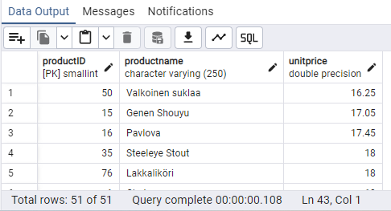

* List all employees who are located in the USA and have the title "Sales Representative".

***Script:*** *select * from employees where country = 'USA' and title = 'Sales Representative';*

***Screenshot:***

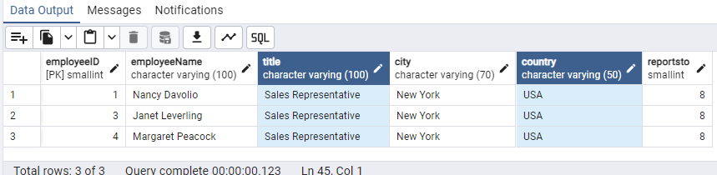

* Retrieve all products that are not discontinued and priced greater than 30

***Script:*** *select * from products where discontinued = 'false' and unitprice > 30 order by unitprice;*

***Screenshot:***

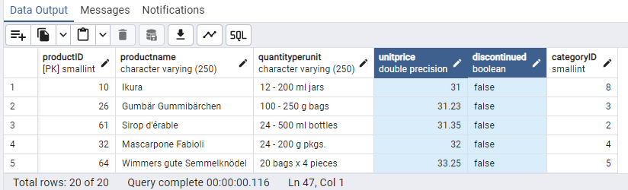

5)      LIMIT/FETCH

* Retrieve the first 10 orders from the orders table.

***Script:*** *select * from orders LIMIT 10;*

***Screenshot:***

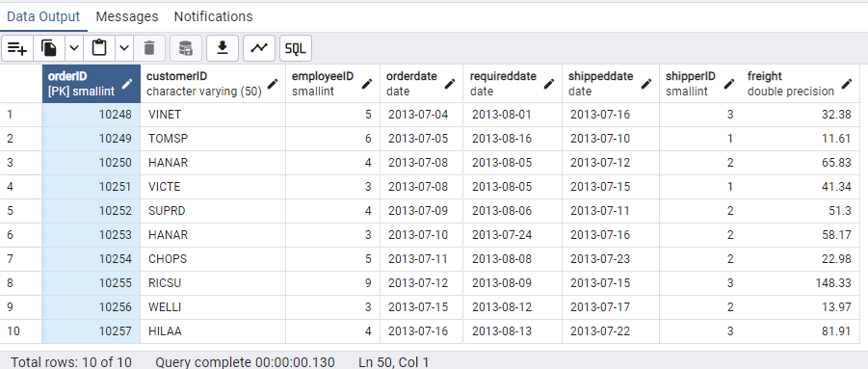

* Retrieve orders starting from the 11th order, fetching 10 rows (i.e., fetch rows 11-20).

***Script:*** *select * from orders LIMIT 10 OFFSET 10;*

***Screenshot:***

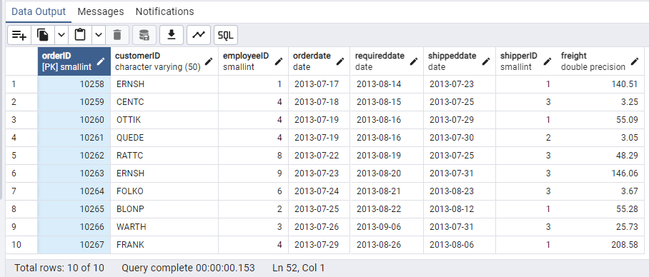

6)      Filtering (IN, BETWEEN)

* List all customers who are either Sales Representative, Owner

***Script:*** *select * from customers where "contactTitle" in ('Sales Representative','Owner');*

***Screenshot:***

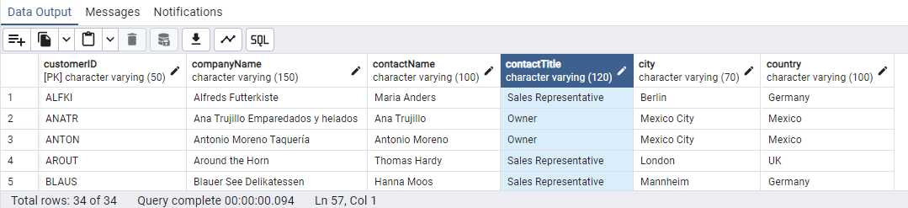

* Retrieve orders placed between January 1, 2013, and December 31, 2013.

***Script:*** *select * from orders where orderdate between '2013-01-01' and '2013-12-31' order by orderdate;*

***Screenshot:***

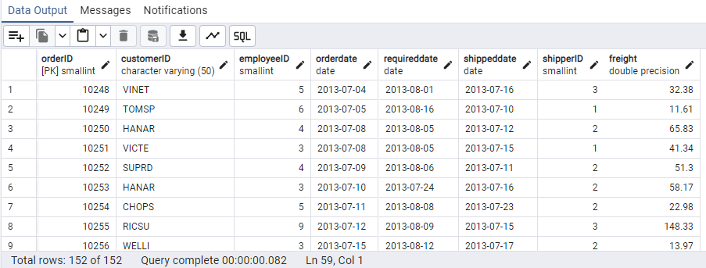

7)      Filtering

* List all products whose category_id is not 1, 2, or 3.

***Script:*** *select * from products where "categoryID" not in (1,2,3) order by "categoryID";*

***Screenshot:***

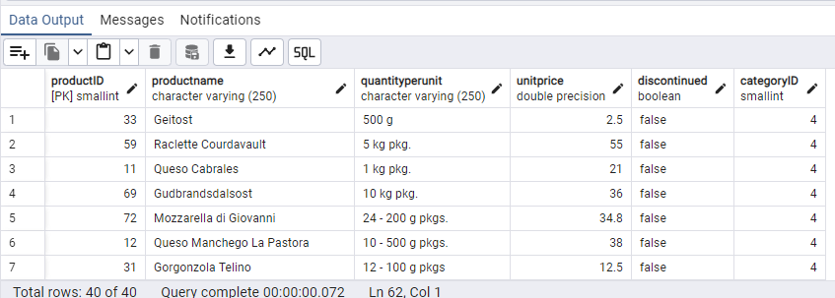

* Find customers whose company name starts with "A".

***Script:*** *select * from customers where "companyName" like 'A%';*

**Screenshot:**

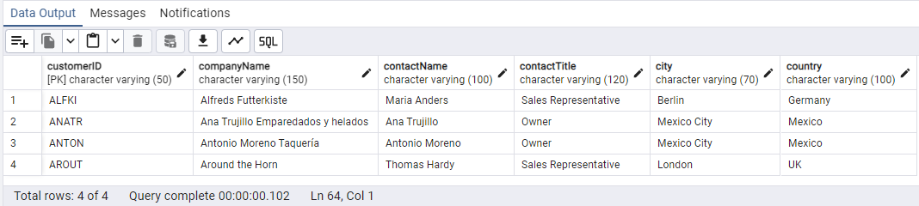

8)       INSERT into orders table:

 Task: Add a new order to the orders table with the following details:

Order ID: 11078

Customer ID: ALFKI

Employee ID: 5

Order Date: 2025-04-23

Required Date: 2025-04-30

Shipped Date: 2025-04-25

shipperID:2

Freight: 45.50

**Script**:

*insert into orders("orderID","customerID","employeeID",orderdate,requireddate,shippeddate,"shipperID",freight)*

*values (11078,'ALFKI',5,'2025-04-23','2025-04-30','2025-04-25',2,45.50);*

***Screenshot:***

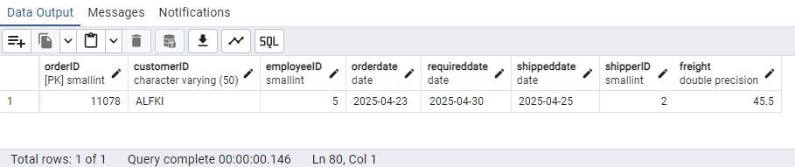

9)      Increase(Update)  the unit price of all products in category_id =2 by 10%.

(HINT: unit_price =unit_price * 1.10)

***Script:***

*Update products set unitprice = unitprice * 1.10 where "categoryID" = 2;*

***Screenshot:***

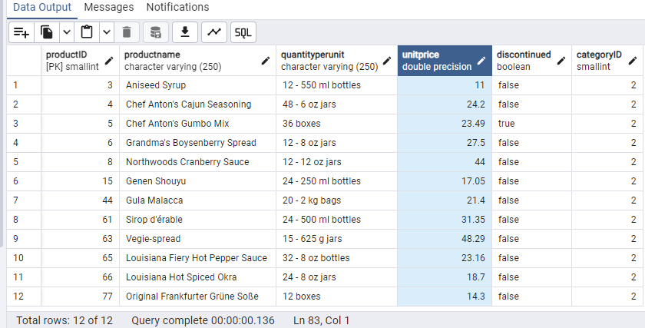

10) Sample Northwind database:

Download

1. Download northwind.sql from below link into your local. Sign in to Git first <https://github.com/pthom/northwind_psql>
2. Manually Create the database using pgAdmin:
   1. Right-click on "Databases" → Create → Database
   2. Give name as ‘northwind’ (all small letters)
   3. Click ‘Save’

Import database:

1. Open pgAdmin and connect to your server
2. Select the database  ‘northwind’
3. Right Click-> Query tool.
4. Click the folder icon to open your northwind.sql file
5. Press F5 or click the Execute button.
6. You will see total 14 tables loaded
7. Databases → your database → Schemas → public → Tables

**Script:** Ran the scripts from the northwind.sql file and below is the screenshot of the db with the 14 tables.

**Screenshot:**

